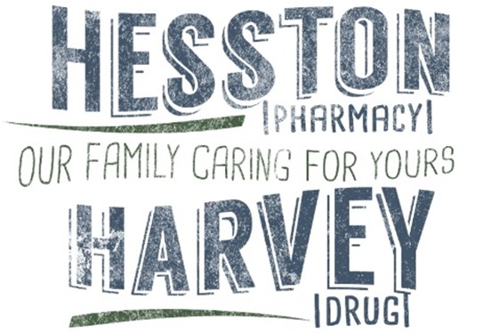
VOLUNTEER HIPAA TRAINING/ATTESTATION:
Privacy and Security
Two words that inspire confidence, give a sense of wellbeing and trust. Privacy and security are two concepts that we often take for granted when it comes to health information. However, taking privacy and security for granted is a formula for failure.

This training familiarizes you with the privacy and security requirements for our volunteer workforce and gives you some guidance on how to do your part. It also addresses HIPAA, a federal law that, among other things, enforces privacy and security requirements.

Privacy

Ensuring the privacy of health information is the obligation of every member of our volunteer
workforce.
In practical terms, this means that you must:
• Determine if information in question is PHI
• If seeking information - do you have a reason to know it?
• If disclosing information - is it being given to someone who has a reason to know it?
• Decide if the reason for disclosure is appropriate

Even when the use or disclosure of PHI is appropriate, we have an obligation to use the minimum necessary information to do the task. However, there are exceptions to this rule. They include uses or disclosures:
• Made to the patient
• For the purpose of treatment outside our pharmacies
• Pursuant to an appropriate authorization
• Otherwise required by the law

To help convey the seriousness of health information privacy and to meet HIPAA compliance requirements, Hesston Pharmacy/Harvey Drug have put into place sanctions for persons who knowingly disclose PHI or otherwise violate HIPAA rules.
For our regular employees these are:
• Verbal counseling
• Written warning
• Suspension
• Termination

It is important to note that a supervisor may skip any and all sanction steps if the
situation warrants.

Workforce members who are not paid (i.e. volunteers) who knowingly disclose PHI or otherwise violate HIPAA rules may be asked to discontinue their volunteer relationship with our pharmacies.

In addition to the ethical issues involved with the privacy of health information and the internal sanctions for violations, there are other issues as well. The first include the loss of trust and possible legal exposure. Significant civil fines and criminal penalties for violations related to inappropriate use and disclosure can also be imposed by the courts.

Security

Security standards are intended to ensure the integrity, confidentiality, and appropriate availability of health Information. As a member of our volunteer workforce, you are essential in making security work.
Some basic security elements include:
• Being aware of your surroundings
• Making sure that appropriate doors are locked
• Logging out of computers when not in use
• Reporting activities that are suspicious or out of place

There are some things that you might not think about as good security practices.
• Good customer service, making eye contact, and greeting people you don’t recognize.

• Answering questions, responding promptly, listening — a person who feels they are being taken care of is less likely to take action that could violate security and privacy.

Summary

Privacy and security of health information are not new concepts. The practice of privacy in the doctor/patient relationship is as old as the profession Itself. However, with the addition of HIPAA, the importance of health information privacy and security is more visible and the consequences of not maintaining it much more severe.

It is our hope that this training has given some insight into basic privacy and security concepts, as well as the more specific issues related to HIPAA. It is by no means meant to be a complete course on the subject. For further information or guidance on a specific issue, or if you have any questions or comments, pleasecontact the Hesston Pharmacy/Harvey Drug Privacy Officer (Adam Kueker 620-327-2211)

I have read the above HIPAA policies and agree to abide by them at all times. I have been given the opportunity to ask any questions and hereby certify that I will follow all of the above guidelines to ensure the security of all patient information.

X___________________________________________________ Date: __________________________

Thank you for volunteering!!!

