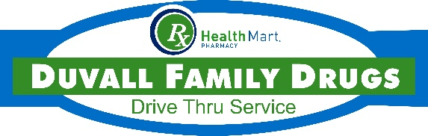
For [Duvall Family Drugs’] COVID-19 Response, we ask for you to be patient as we care for you!
We are taking the following steps to protect you, and this will allow us to protect our staff in order to maintain our service and commitment to you.
We have 5 points that you need to be aware of during this time. Please read closely.
- When you receive a call from the pharmacy, please answer.

- Calling in prescriptions: Please wait until you are notified that med is ready for pick-up.
  - Please download our App: [Insert App Name]
    - Reason: Makes 2 -way communication between us and you EASIER

- Arriving at the pharmacy: The front door is locked, but we are open.

- Picking-up your prescription, OTC, or, gift: Drive-thru OR we can deliver in the parking lot. We have designated signs in the parking lot. Please have payment ready!
* You DO NOT have to call us if you’re in the drive-thru
*Let us know your name, vehicle description, and parking spot number
3 ways to let us know you’re in the parking lot:
- Text us at [Insert Secure Texting Number]
- [Insert App Name]: please text us directly from the App.
- Call (last resort): [Insert Phone Number]

- Medication synchronization: We will call you one week prior to fill your medications.
*Please be mindful to answer our phone calls to expedite the process.
- Ask us how to enroll if you are not already!
- Your chronic conditions are very important to be under control always- especially now. This is a way we can check-in on you & communicate to your prescriber when needed.
Currently available over-the-counter products
- Thermometer (Limit: one per family)
- Cough Suppressants
- Cough Drops
- Allergy Medications
- Acetaminophen (Tylenol) to reduce fever
- Immune System Boosters: Vitamic C, Elderberry Syrup, Zync

Let us know what you need! We will bring it out to you.

We do not have: Masks, Sanitizers, Alcohol

